**Project Development Phase**

|  |  |
| --- | --- |
| **Date** | **02 November 2022** |
| **Team ID** | **PNT2022TMID50712** |
| **Project Name** | **Smart Fashion Recommender Application** |

**SENDGRID INTEGRATION WITH PYTHON CODE:**

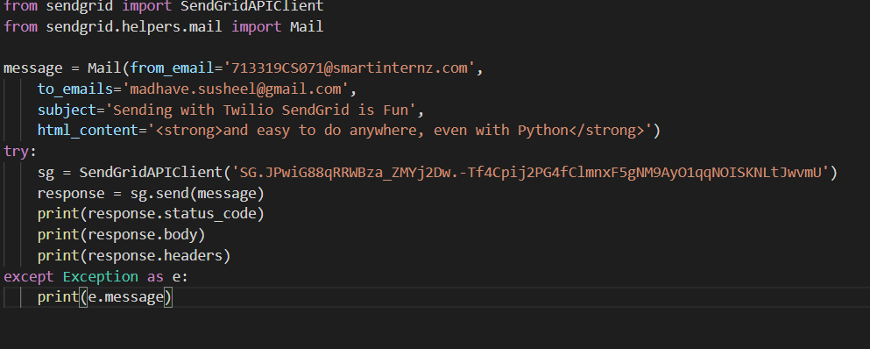

**EMAIL FROM SENDGRID:**

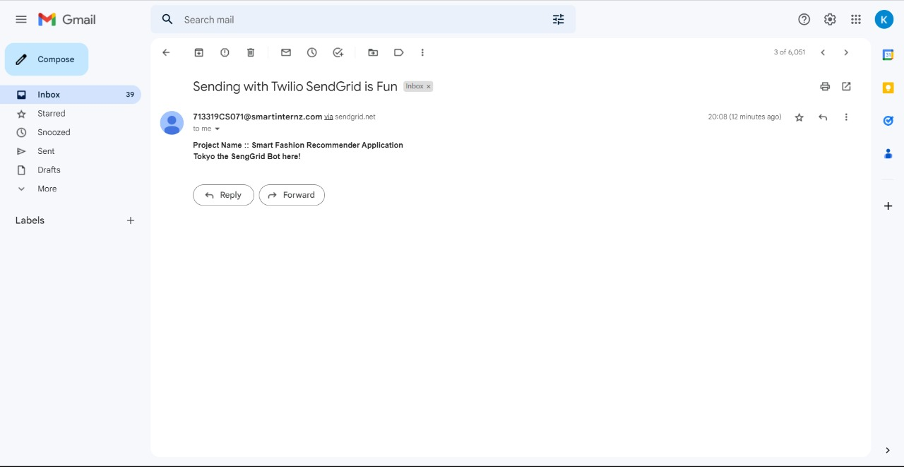

**BUILDING A CHATBOT:**

